# User Manual for Assignment 2 Android App

## By Pengbo Xue

Welcome page:

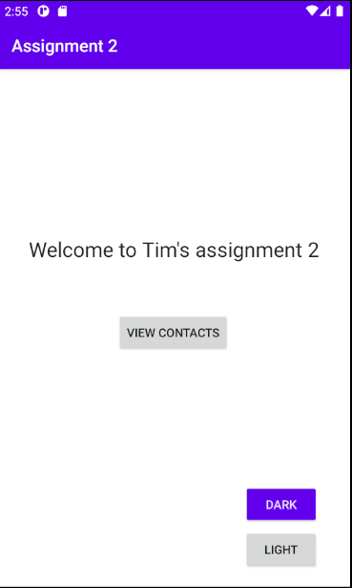

Click on the “dark” button for dark theme, click on light button to change back to “light” theme:

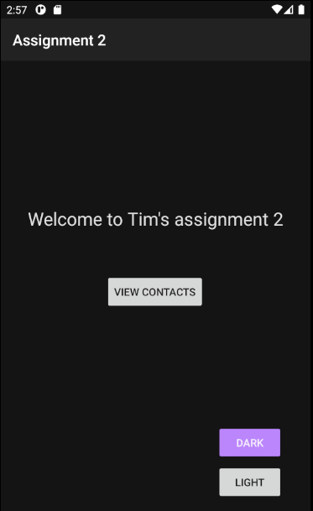

Click on the “View Contact” button to see the contact list:

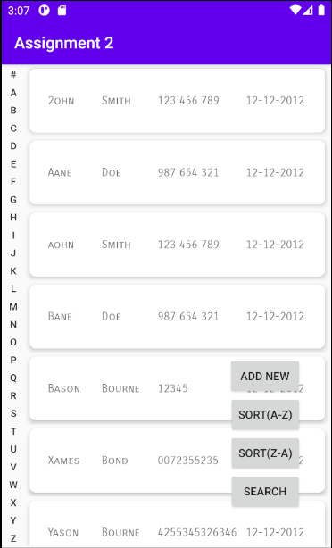

Fling any of the contact card to reveal the detail button:

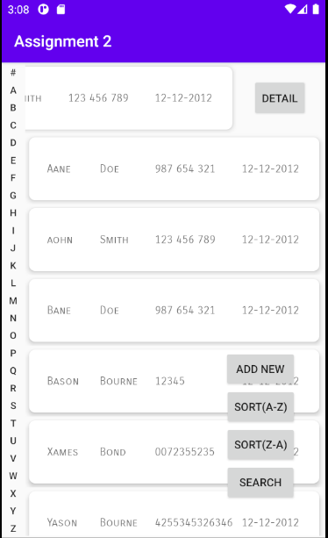

Click on the “Detail” button to see the details, edit, delete, and make phone called.

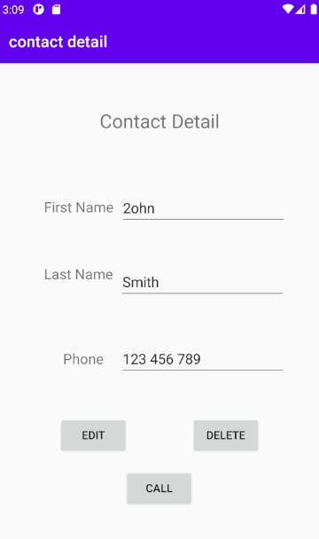

If you wish to edit the contact detail, press the “Edit” button after the field has been filled out correctly:

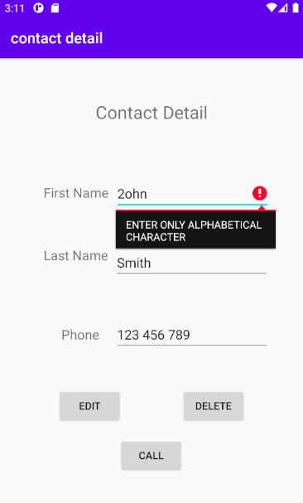

You should land on the contact list page if the edit is successful:

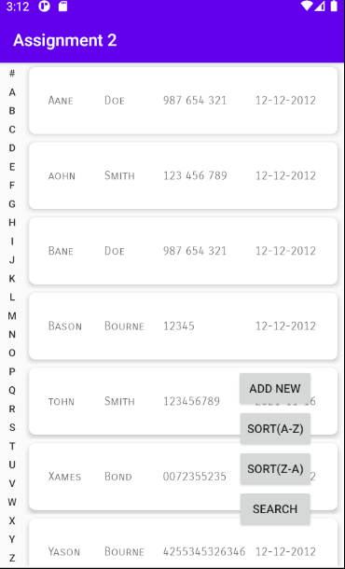

Click on the ”Delete” button to delete the record:



You should land the contact list page after, with the record already deleted:



Click on the call button in the detail page to make a phone call to the number recorded:

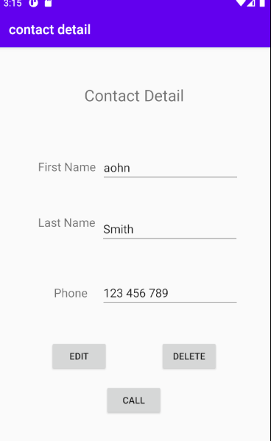

The phone application should open after the button click.

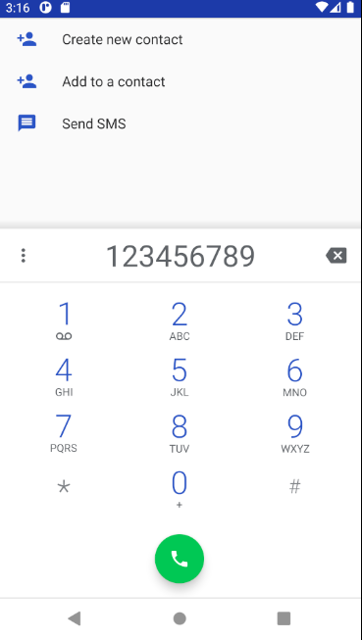

Clicking on the “Add New” button in contact list page to add a new record to the phone book:

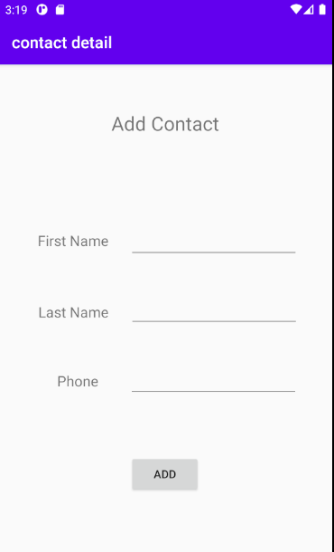

Make sure the fields are filled in correctly before adding the record.

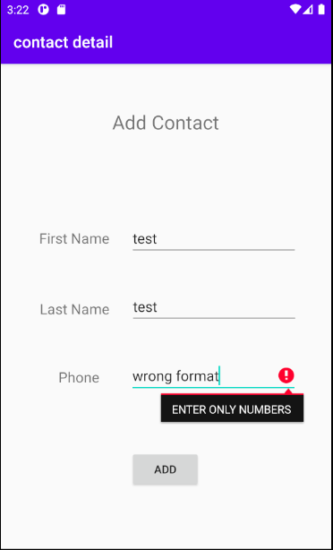

Once clicking add button the new item should be added to the database and being displayed on the contact list page.

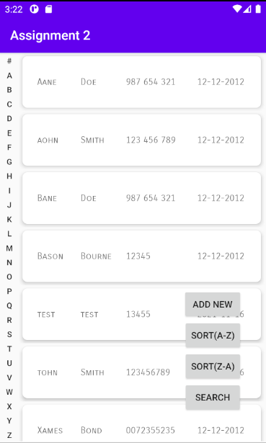

Click on the sort button to sort the contact list page from Z-A or sort it from A-Z.

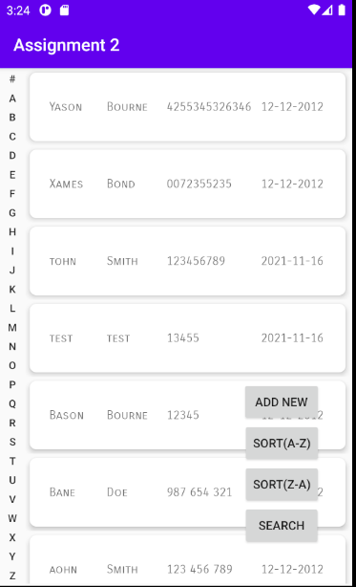

Press on the search button to search for people with certain name.

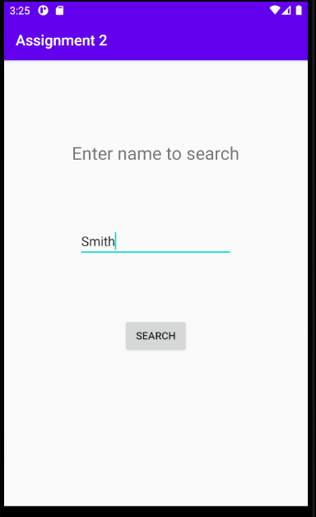

The contact list should display with only matching result.

